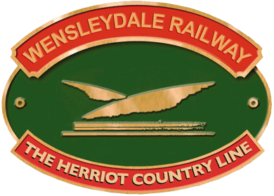**Wensleydale Railway Map Skills Activity**

Let’s hope the Station Master doesn’t get lost without his Map!

Have a look at the map of the Leeming Bar area and then test out your map skills with the questions below.

**Questions**

1. What are the coordinates of Richmond and Northallerton Railway Stations?
2. What can you find at the coordinates (094,035)?
3. What are the coordinates of Welbury Police Station?
4. What are the coordinates of the Place of Worship nearest to Hornby?
5. Is there a campsite at (042,061)?
6. Is there a Place of Worship at (057,027)?
7. On your map, The Wensleydale Railway Line runs from Leyburn Station at 000,034 to Northallerton Station at 080,042. Find the following coordinates and circle the ones that the Wensleydale Railway Line runs through. Remember, the Railway Line is the dark line, which you can see on the Map Key.

(020,032)

(050,040)

(035,028)

(071,039)

(045,022)

(065,037)

1. What are the starting and ending coordinates of the Public Footpath that runs through Middleton Tyas?

Now it's time to get creative – have a go at making your own map symbol and choose the map coordinates where you think it should belong.

Step 1) Think about something that you may need a symbol for that isn’t on the current map. It could be something that didn’t exist in the 1920s, it be anything, from a Post-box to a scarecrow!

Step 2) Design your map symbol. Don’t make it too complicated, as it has to be something that you can draw small and is easily recognisable.

Step 3) Choose its coordinates on the map. Think about where your symbol might need to be. Does it need to be near to a town? Would it be along a road? Or maybe it can be right in the middle of a field. Write out the coordinates for your new symbol.