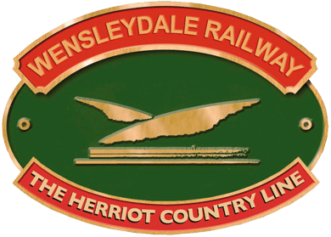KS1 Loan Box – Emily Plews

Beetle – Game Sheet

What might Emily do to pass the time on her long train journey to the beach? Play a game called Beetle with her sisters! Usually, players must complete a beetle bug, but how about we do it with a train instead?

Instructions

Players take turns rolling a dice (youngest goes first). Depending on what number is rolled, the player gets to draw a different part of the train that you can see below.

However, players cannot draw any part to begin with. Each player must roll both a 5 and a 6 so that they can draw the cab (5) and the boiler (6) first.

Once you have rolled a 5 and a 6 to draw the cab and boiler, you can start drawing the other parts in whatever order you roll them in.

Some numbers match up to more than one part of the train – but you can only draw one piece at a time, so you will have to roll these numbers more than once.

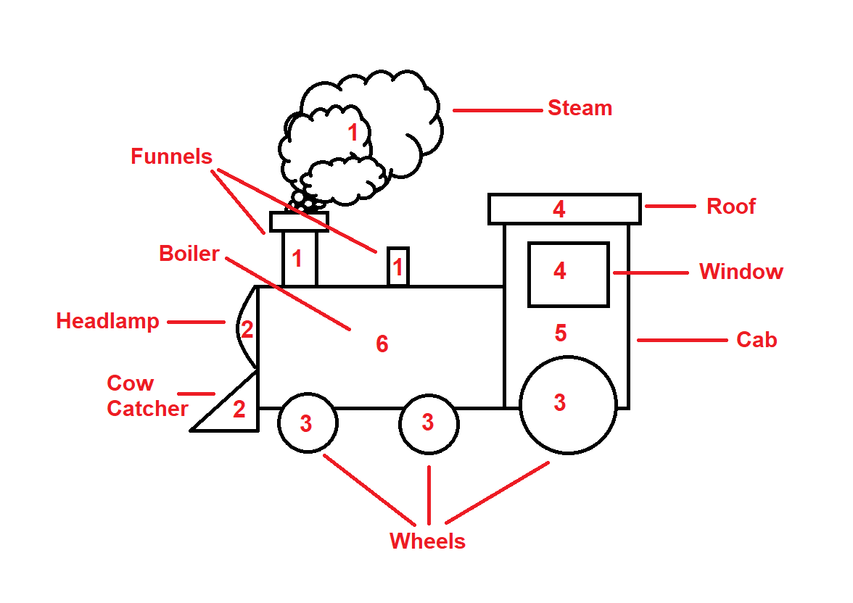Whoever can complete the train first wins!

